Placement Data
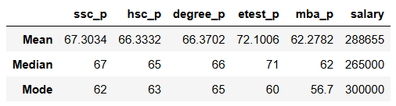

The data shows that average percentage of students in ssc, hsc, degree and mba is slightly above average
Since median and mean values of ssc, hsc, degree, etest and mba are almost similar there are no outliers.
But salary may have an outlier since the mean and median varies and mode has a larger value than them

